David Schroeder

ITP 303 Final Project Proposal

1. Topic

I am going to create an event website that shows events that your friends are organizing and which ones are going on at your university.

1. Audience

My audience would be sociable people of all ages that want to know about events around them

1. Design & Style
   1. Discuss design and color scheme in 2-3 sentences.

I’m thinking that the website will be simplistic but elegant with an orange color scheme. I want the website to have a modern, welcoming feel. I think that the boxes and containers involved will have soft edges to create this modern atmosphere.

* 1. Provide links to 3 websites that inspired your design.

hype4.com

paymoapp.com

creativespark.co.uk

1. Scope
   1. How many pages are you planning to have?

8

* 1. What are the pages?

A home page, a search results page, an event page, an add event page, a delete event page, a profile page, a sign in page, and a create account page

* 1. If it is a single page website, how many sections are you planning to have?
  2. What are the sections?

1. Database
   1. What data will be stored in the database?

The profile information and the event information

* 1. Where is data coming from?

Some will be hardcoded in, but the user can also create an account or add or delete events

1. Database Diagram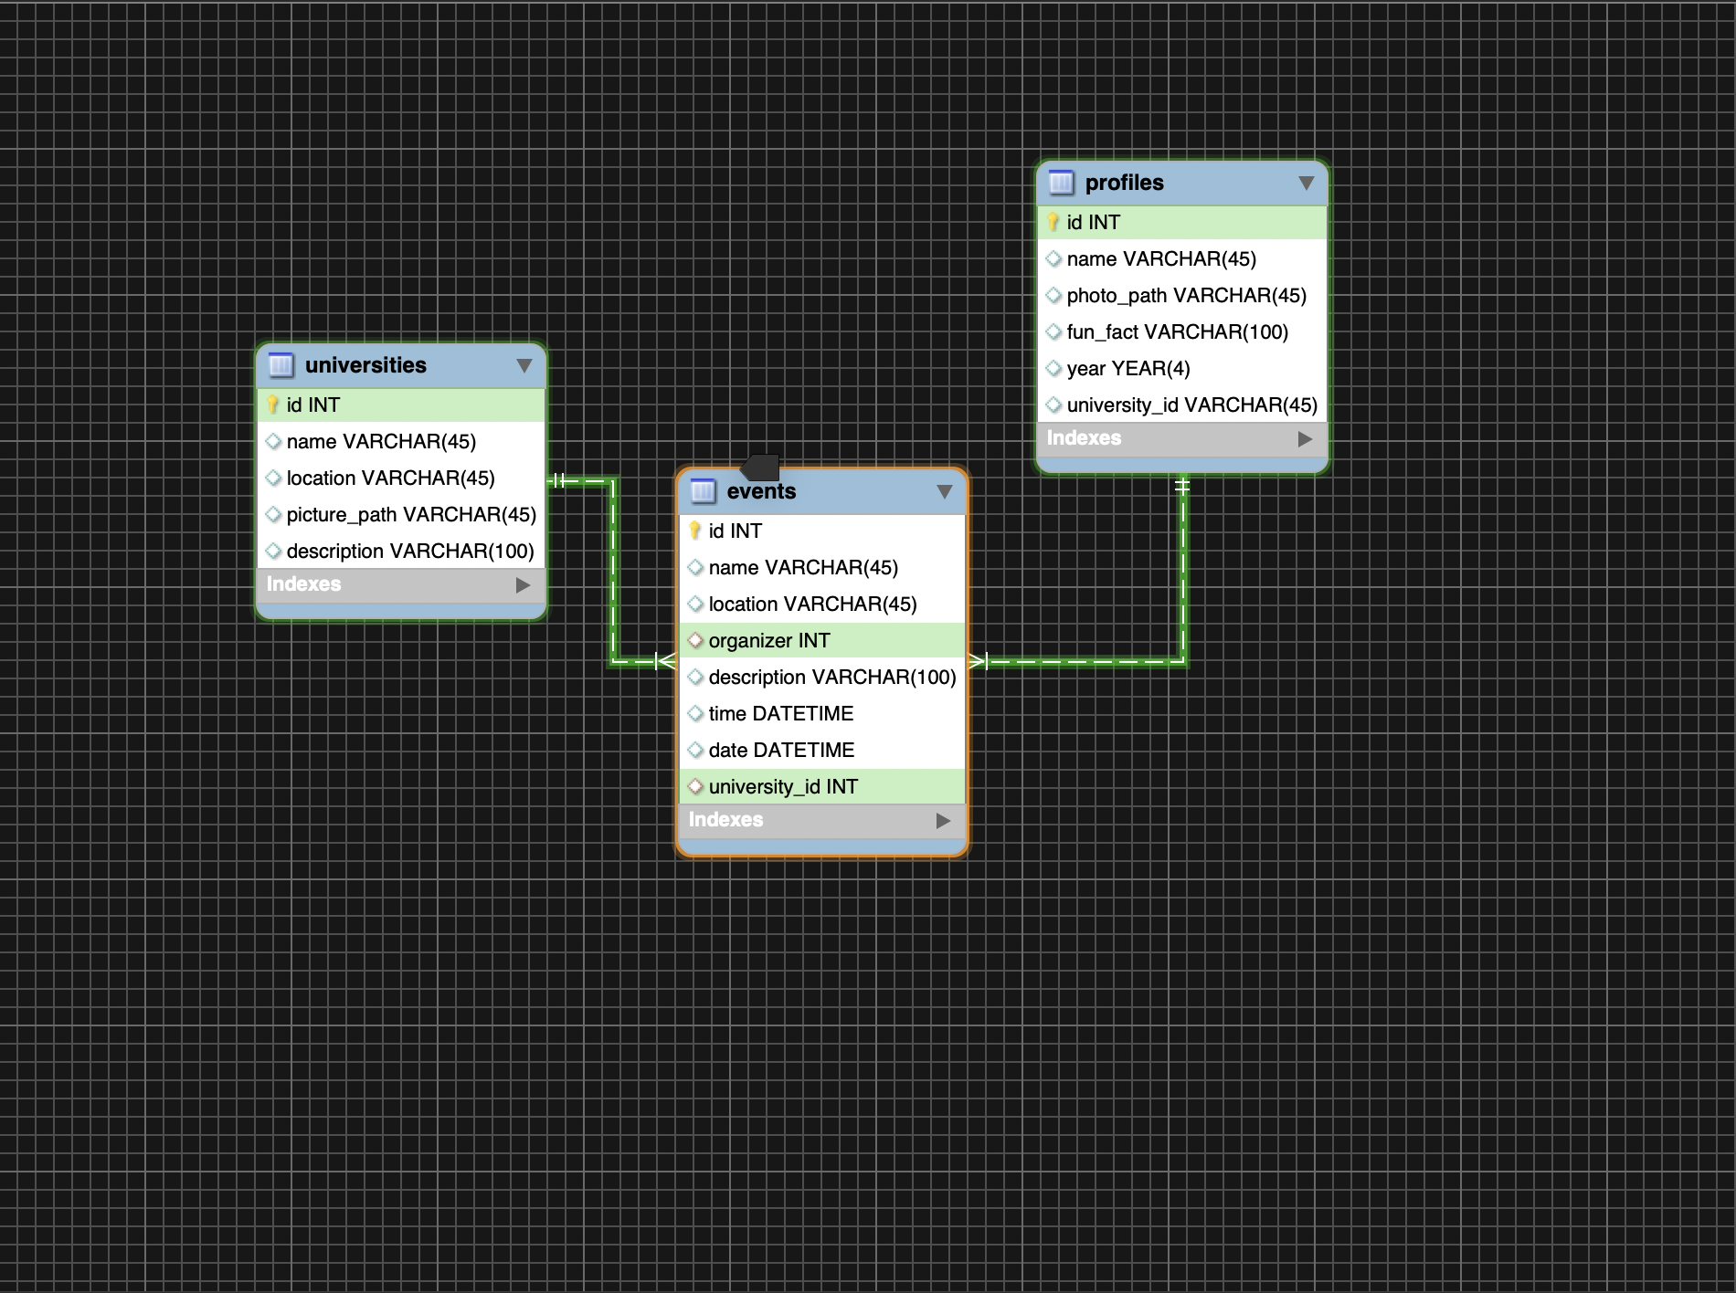

Wireframes:

Event – Mobile: Home- Mobile

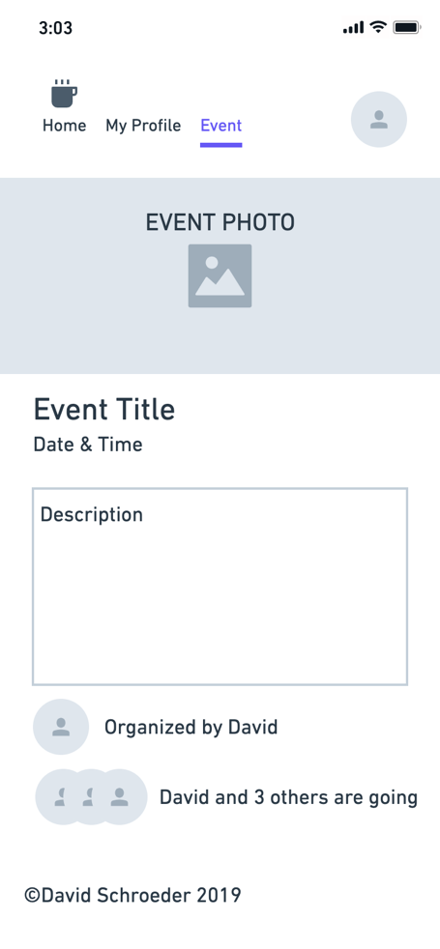 ` 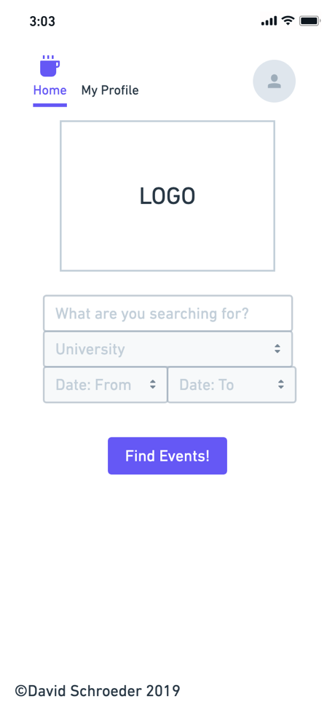

Event - Desktop:

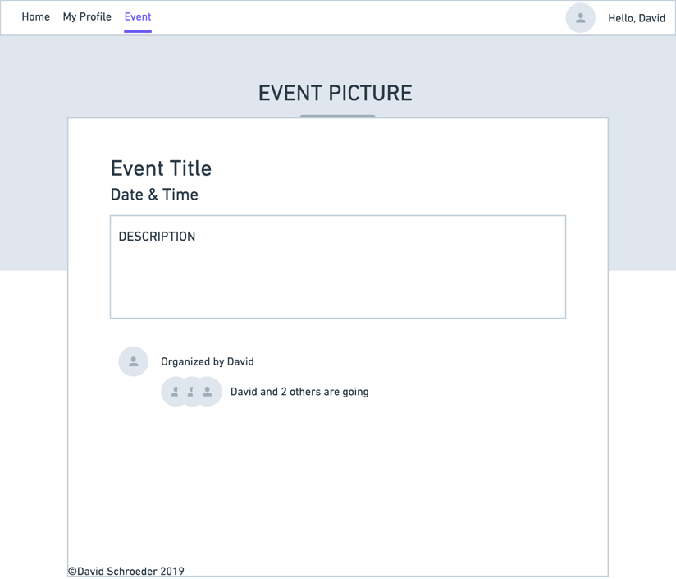

Home- Desktop:

